Presentation of the UG Major Project
Structure, content and format
6,000 words
Breakdown of project into sections/chapters

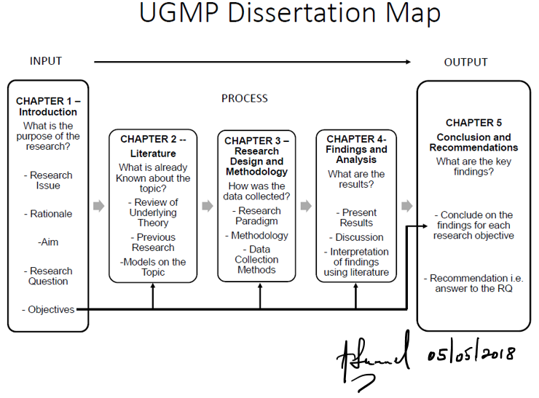

Title Page
Declaration Page
Acknowledgement
Abstract:
An abstract serve as a brief overview of the project. Its purpose is to provide a paragraph that someone can read and decide if they want to read the project in more depth. Therefore, it should contain all the major elements of your project in a condensed form.
Structure of an abstract: Five sentences, introduce the topic, state the problem you tackle, why is it important/why has nobody sufficiently answered the issue yet? What you did (methods), what you found.
Abstracts are usually written once the project has been written up
Approx. word count 250 (not included in 6,000 words)

Table of Contents:
An outline of the whole project in list form, setting out the order of the sections, with page numbers. It is conventional to number the preliminary pages (abstract, table of contents) with lower case Roman numerals (i.e. (i), (ii), (iii) etc.) and the main text pages (starting with the first chapter) in Arabic numerals (1, 2, 3, etc.) as shown below:
Contents Page
List of Tables i
List of Figures ii
List of Abbreviations iii
Acknowledgements iv
Chapter 1 (Title) 1
1.1 (First section heading)
1.2 (Second section heading)
1.3 (Third etc.)
Chapter x (Title) y
x.1 (First section heading)
x.2 (Second section heading)
x.3 (Third etc.)
References
Appendices

Chapter 1 Introduction:
Introduce the topic and background
Provide rationale for the study
Why is it timely, relevant and interesting?
Introduce focus of the research; aims; objectives; research questions and how you will carry out the research
The organisation of this dissertation
Approx. 700 words

Chapter 2 Literature review:
A key purpose of this chapter is to demonstrate understanding of current research that has been conducted in your field, and to identify gaps in the knowledge, or areas where understanding could be further developed.
Set up your conceptual/theoretical framework – this is particularly important if you are doing secondary research. What concepts have been identified in the literature already?
Start broad and narrow focus down. Conclude literature review with reminder of research objectives/questions.
Approx. 1300 words

Chapter 3 Methodology:
Essential contents – philosophical underpinnings of methodology, including ontological and epistemological positioning.
Research design – Structure like the research onion – explain choices from the outer ‘skin’ through to the interior.
Data collection methods – what you actually did to collect your data.
Data analysis – how you analysed the data collected.
Strengths and limitations of methodology – no research is perfect, there are pros and cons of any approach. What did you do to minimise limitations?
Ethical considerations – how did you ensure that you conducted an ethically sound piece of research? Make sure you complete the ethics form and quiz.
Methodology = both the philosophical aspects of your study, and an instruction manual / recipe so that someone else can follow step-by-step to replicate your work.
Approx. 1300 words

Chapter 4 Findings and Discussion:
A Presentation of your research results. The findings should not just be a list of bullet points, or a string of quotes. All secondary data presented here should be analysed using the literature reviewed and clearly address your research objectives/questions or hypotheses.
This chapter also integrates your data / results and your literature review. Make sure you return to the key papers, themes, ideas, concepts, evidence (etc) that you have highlighted in your literature review. How does your data match / contradict the literature you have consulted?
Theoretical analysis included here – analyse your findings in terms of a key theory/conceptual framework. E.g. How do your findings fit into a particular framework/theory of understanding?
Approx. 2000 words

Chapter 5 Conclusion:
Summarise the key findings of your study. Outline your previous work. Then discuss:
What are the theoretical and practical implications of your findings?
What are potential limitations of the study as a whole?
What are your recommended directions for future research? (the potential limitations should help to lead you to recommendations e.g. small sample size as a limitation = larger scale study in the future)
Approx. 700 words

References:
These should be listed in alphabetical order following the ARU/ Harvard referencing style explained here: https://library.aru.ac.uk/referencing/harvard.htm Only the references cited in your dissertation should be included (not bibliography). If sources are used which are not written in English then the English translation is required.
Appendices:
These should only contain material which is genuinely supportive of the argument in the chapters of the dissertation.
- Supervisor Log
- Ethics Quiz Certificate

Suggested Format
Your dissertation must be written in English in typescript form on letter size page
You must submit one digital copy through Turnitin as explained above. You should also retain a copy in case any issues occur with your submission.
Type double spaced or 1.5
Margins should be approximately: 2.54 cm on ALL sides of the page
You can include your SID in either the Header or Footer of the page
Pages should be numbered in a single sequence from the contents page onwards.
Short quotations can run in the text within single quotation marks (double quotation marks reserved for quotations within quotations). Quotations longer than about 30 words should be set in from the right-hand side of the page (normally the indent should be more than the paragraph indent).
Always write in complete sentences. Do not resort to note form.
All abbreviations must be explained when they first appear and included in the front of the document following the contents page and the list of tables and figures.
A table is a presentation of data in tabular form; a figure is a diagrammatic representation of data or other material. Tables and figures should be clearly and consistently numbered, either above or below the table or figure. Each table and figure should have a separate heading (caption). The reader should be able to understand what the table or figure is about from this heading / caption without referring to the text for explanations. The numbers of the tables and the figures you use in the text and in the lists at the beginning should correspond exactly.

